HANDBOOK OF FIBER OPTIC PROBES
by
Sean Mueller

Outline

Page
Chapter 1: A Brief Introduction to Fiber Optics 3
Chapter 2: Tools of the Trade 11
Chapter 3: Step by Step Instructions 17
1.1 A Brief Tutorial on Fiber-Optic Probes
Every medium has a refractive index, which is always greater than one since the refractive index is defined as:
Snell’s law simply states that that at the boundary between two media, light bends away from the normal (a line perpendicular to the surface) when it enters the optically less dense medium, and bends toward the normal as it enters the optically denser medium. Snell’s Law, shown in Figure 1, describes optical transmission.
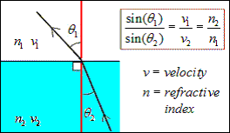
Figure 1. Snell’s Law.
Now consider the situation where n₁ > n₂ and light is traveling in medium 1 toward the interface. The following possibilities are depicted in Figure 2.
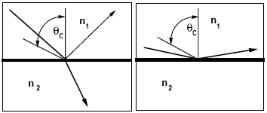
Figure 2. Partial Reflection (left) and Total Internal Reflection (right).
Depending on whether the incident angle is less than or greater than the critical angle, θ_{c}, the ray of light in medium 1 can either partially transmit to medium 2 or totally reflect back into medium 1. A fiber optic cable employs the scenario shown on the right in Figure 2. (If n₂ > n₁ in the above scenario, the light would completely transmit from medium 1 to medium 2.)
Figure 3. Light Propagation due to Total Internal Reflection.
In Figure 3, light in the core that strikes the cladding wall at an angle greater than the critical angle will totally reflect and then strike the opposite wall and repeat this process all the way down the length of the fiber.

1.2 The Principle of the Fiber-Optic Probe in Gas-Liquid Systems
As an example, the probe response to a bubble striking a single probe tip is shown schematically in Figure 4.
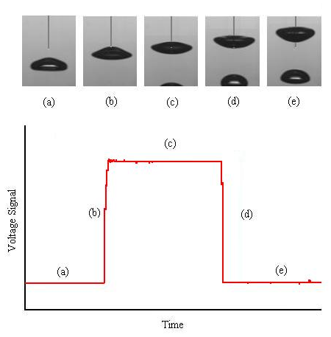
Figure 4. Characteristic Step Response of a Bubble Striking the Probe Tip:
(a) and (e) show the probe response in the liquid, (c) the response in the gas, and (b) and (d) the response of the tip entering and leaving gas/liquid interface.

The reason that the response in Figure 4 is possible is because the tip of the fiber-optic cable is tapered into the shape of a cone (Figure 5).
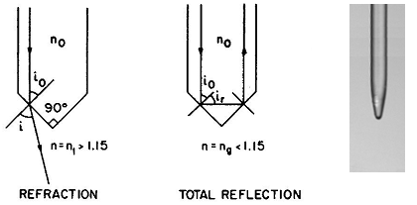
Figure 5. Refraction, Total Reflection, and Image of an Actual Probe Tip.
Since the refractive index of the glass core is approximately 1.5, the light refracts or reflects based on its angle of incidence with the conic end and based on the refractive index of the medium surrounding the probe tip. Thus, the probe is able to sense changes between gases (n1) and liquids (n1.3-1.5), and G-L boundaries can be easily determined.
The opto/electrical components (termed “fiberbox”) needed to generate and acquire the signal are shown in Figure 6.
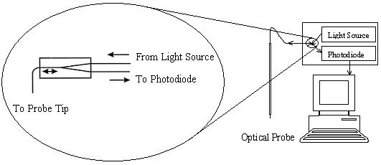
Figure 6. Fiber-Optic Coupling and Probe Tip.
The light source focuses light into one leg of a fiber optic coupler, which relays the light to the probe tip. When the tip is in the presence of gas, most of the light internally reflects and travels back up the fiber. When the tip is in the presence of a liquid, most of the light refracts out into the liquid, and very little light travels back up the fiber. The light traveling back up the fiber re-enters the coupler, which sends a percentage – usually 50% – of this reflected light down the other leg of the coupler to a photodiode. The photodiode then converts the quanta of light into a voltage signal for much like that in Figure 4.

1.3 How the Probe Works
Optical probes developed here at Washington University have been used successfully in churn-turbulent bubble columns to measure bubble velocity distributions, bubble chord length distributions, local gas hold-up profiles and specific interfacial area at pressures up to 10 barg, but that has been the extent of its use. The probe design will be discussed briefly here, but for a thorough discussion please refer to Junli Xue’s thesis.
The optical probe design consists of 4 polymer-jacketed, fiber-optic cables with glass cores of 200 μm arranged in the geometrical configuration shown in Figure 7. The fibers are then glued into 1/8” stainless steel tubing for insertion into the reactor.
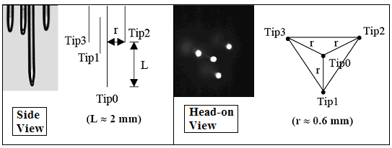
Figure 7. Probe Dimensions used in Bubble Column Studies.
The dimensions of tips 1, 2, and 3 are all relative to tip 0. Looking at the dimensions, the cross sectional diameter of the probe is 1.4 mm (including the actual dimensions of the glass cores).
Please keep in mind the typical picture (Figure 8) of a bubble strike interaction with all four tips. The following sections will discuss how the needed bubble dynamics are obtained from signals such as those presented in Figure 8.
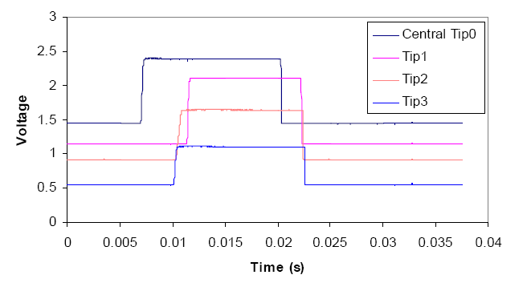
Figure 8. A Bubble Striking a 4-point Probe.

1.3.1 Measuring Gas Hold-up
The overall gas hold-up is defined as the ratio of the volume occupied by gas divided by the total volume of the G-L mixture:
However, local gas holdup – the average holdup at a specific point in the reactor – is much more valuable for describing fluid motion within the reactor.
Local gas holdup is defined as the fraction of volume occupied by gas within a certain volume of interest within the fluid mixture:
By invoking the ergodic hypothesis, which states that the ensemble average is equivalent to the time average, the spatially (volume) averaged local holdup can be replaced by its equivalent time-averaged local holdup:
Here the time-averaged local gas hold-up is defined as the ratio of time spent in the gas phase divided by the overall measurement time for a particular point of space within a vessel.
By placing a single-tip optical probe in a specific point in a G-L system, the local hold-up is easily obtained by counting the total time spent in the gas phase (hundreds of bubble strikes) and comparing that time to the total measurement time (provided that the total measurement time is sufficiently long to provide a good statistical representation for the sampled point). The overall hold-up can then be deduced from the radial and axial local hold-up profiles.

1.3.2 Measuring Bubble Velocity and Bubble Chord Length Distributions
Imagine a bubble striking the probe as is shown in Figure 10.
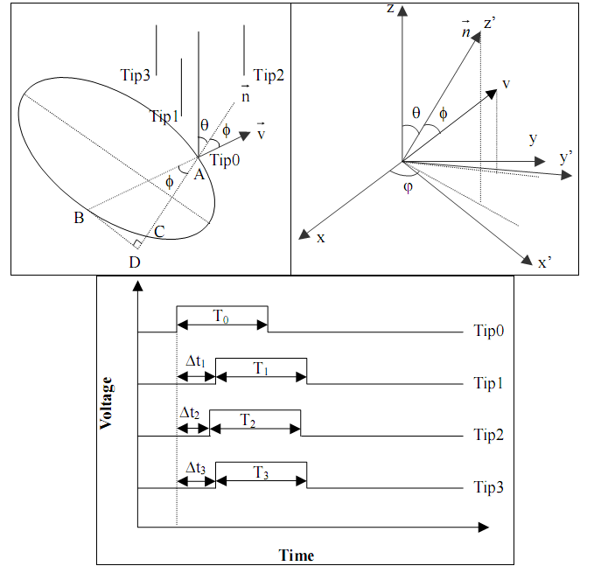
Figure 10. A Bubble-Probe Interaction.
Here, is the normal vector of the bubble, is the velocity vector of the bubble, is the deviation of from (usually very small), and ϕ and θ are the angles of approach of the bubble. Following Xue, after the appropriate coordinate transformation, the time intervals between the instant when a bubble hits the central tip, Tip 0, and when it hits Tips 1, 2, and 3 are:
The 3 unknowns in the above equations are θ, ϕ, and . The three equations are non-linear but can be solved numerically. Thus, assuming that the deviation of the bubble’s velocity vector from the normal is small (and therefore is approximately 1), the velocity vector can be determined when a bubble interacts with the 4 probe tips. Once the velocity is known, the bubble chord length pierced by tip i is simply
With the interaction of multiple bubbles with the probe, a chord length distribution is obtained. Bubble size can then be determined if a bubble geometry (spherical, ellipsoidal, etc) is assumed. However, bubbles in turbulent flows often fluctuate from a specific geometry. Thus, while a Sauter mean diameter can be calculated for an ellipsoidal bubble, it does not physically describe the actual bubble; an accurate method to determine bubble size from chord length distributions does not exist.

1.3.3 Measuring Specific Interfacial Area
Kataoka et al. derived the equation for specific interfacial area.
Here N is the total number of the gas-liquid interfaces passing by the probe during the measurement time ΔT, and φ is the angle between the velocity vector and the normal vector of the bubble’s surface (Figure 11).
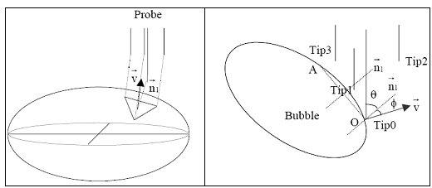
Figure 11. Measuring Specific Interfacial Area.²³
The equations describing the velocity of the bubble’s surface section pierced by the probe are:
The unknowns are now θ, ϕ, and , and the three equations can be solved to find which can then be used in Kataoka’s equation to directly determine interfacial area without assuming bubble geometry.

2.1 Tools of the Trade: What You’ll Need to Manufacture Your Own Fiber-Optic Probes

- An open workspace equipped with a table and chair.
- A hydrogen cylinder and oxygen cylinder equipped with regulators and a flame torch (shown below in Figure 12).
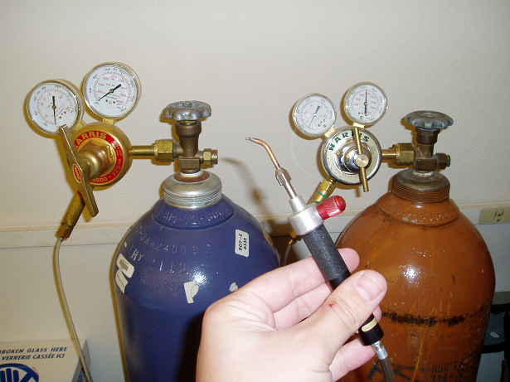
Figure 12. H₂/0₂ Cylinders and Torch.
- Glass, multimode fiber optic cable, 200 micron core, 230 micron clad, 500 micron coat (about 100 meters to start). Part #: BFL37-200 from Thorlabs.com, $US 0.90 per meter.
- Scissors for coarsely cutting the fiber optic cable.
- A fiber stripper for stripping the jacket off of the fiber. Part #: T12S21 from Thorlabs.com $US 65.00
- A stand with a clamp arm for suspending the cable in order to cut the fiber with the torch. Shown below in Figure 13, the clamp arm holds a short section of stainless steel (SS) tubing with a ½” section of soft, flexible tubing fitted at the top of the SS tubing. Once the fiber is threaded through the tubing, a clip is used to pinch the soft tubing in order to hold the fiber in place and prevent the weight from pulling the fiber down
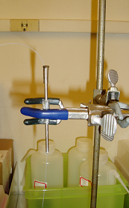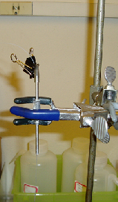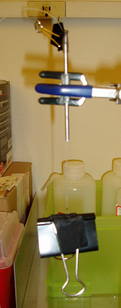
Figure 13. Stand for Suspending the Fiber Optic Cable for Flame Cutting.
- A weight to hang from the bottom of the fiber in order to make the proper cut (shown below in Figure 14). The weight is simply a large clip with some soft tape on it to prevent the clip from pinching too hard on the fiber (and thus damage to the fiber).
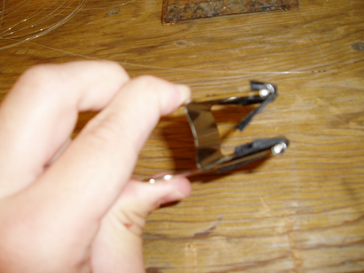
Figure 14. Weight Used to Pull the Fiber Optic Cable Taut.
- A diamond-tipped fiber scribe in order to trim the fiber tip after it has been cut. Part #: S90W from Thorlabs.com
- A microscope equipped with a light in order to trim the fiber with the diamond-tipped cutter (shown below in Figure 15).
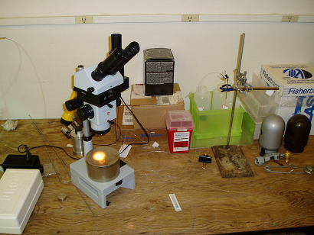
Figure 15. Microscope Used for Inspecting the Fiber Tip.
- A jig for positioning the 4 tips into the 3-D array shown below in Figure 16. (see Junli Xue’s thesis – this will have to be made in a machine shop)
Figure 16. Plastic Jig for the 3-D Array.
- Devcon 5-minute epoxy for gluing the fibers in place. $US 5.00
- Stainless steel tubing (1/8” OD, 0.105” ID) for mounting the 3-D array with epoxy (on average 12-18” needed per probe). $US 13.87 per 28”.
- A tube bender for bending the SS tubing (if desired). Part #: 2492A12 from McMaster-Carr, $US 28.52
- A fiber cleaver for making flat, clean cuts on the back ends of the probe. Part #: XL410 from Thorlabs.com, $US 1360.00
- An SMA Connectorization Toolkit for making SMA connections. Part #: CK01 from Thorlabs.com (this includes the diamond-tipped fiber scribe), $US 542.00
- A Sharpie pen, lockable tweezers, a pointed pair of tweezers, toothpicks, and masking tape.
  - TOTAL ~ $US 2200.00 (not including the microscope and cylinder/torch)

2.2 Tools of the Trade: Opto/electronics for Data Acquisition

- A computer workstation equipped with a good processor, storage capacity and RAM – you’ll need to have Fortran installed to run the data processing algorithm.
- A data acquisition board for high-speed measurements. Part #: PD2-MFS-8-1M/12 from PowerDaq. ~$US 3500.00
- Four BNC cables. Part#: 2249-C-36 from Pomona, ~$US 15.00 per cable.
- Four multimode fiber splitters (couplers). Part #: 15-32200-50-11301 from Gould Fiber Optics, $US 150-200 per splitter
- A bright light source (or 4 laser diodes of ~700 nm wavelength such as CPS198 from Thorlabs.com with power supplies) to shine into one leg of the couplers.
- Four photodiodes for generating the voltage signals from the light responses. Part #: PDA10A from Thorlabs.com, $US 278.00 per photodiode.
- Four SM1SMA connectors for connecting the fiber to the photodiode. Part #: SM1SMA from Thorlabs.com $US 26.00 per connector.
- Four SMA connectors to route one leg of the coupler to the photodiode. Part #: 10230A from Thorlabs.com, $US 9.45 per connector.
- Four grey, 1/8” OD PVC tubes (about ¾” long) with 525 micron bore through the center (along the axis of the tubing) to align the fiber of the coupler with the fiber from the probe. (this connector will have to be made in the machine shop) The schematic of the connector is shown below in Figure 17.
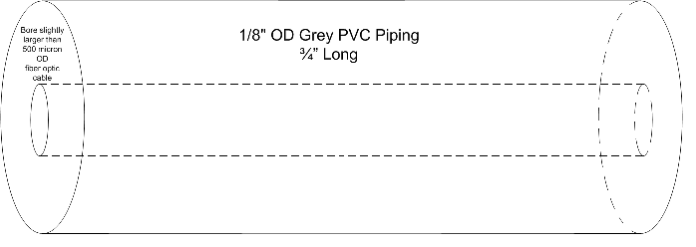
Figure 17. Schematic for PVC Connector (for connection between the probe and the fiberbox).

- Index matching gel for making clean connections between the probe and the couplers. Part#: G608N from Thorlabs.com
  - TOTAL ~ $US 5700.00 (not including computer or light source)
3.1 Step by Step Procedure for Making the Fiberbox (opto/electronics)

- Strip about 1” of the jacket off one leg of each coupler and attach the SMA connector to that leg. Follow the instruction included in the Connectrorization Toolkit Manual to attach the SMA connector and polish the ends.
- Install the SM1SMA connector on each of the photodiodes and then screw in each of the SMA connectorized legs of the coupler.
- Connect each photodiode to the data acquisition board with the BNC cables.
- Mount the other legs of the coupler in the light source.
- Insert the remaining end of the coupler into each of the grey PVC connectors to be ready for connection with the probe.
- The opto/electronics setup (Fiberbox) is now complete. The general schematic is shown below in Figure 18.
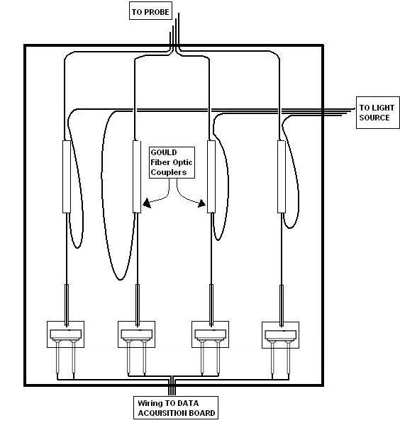
Figure 18. General Concept of the Fiberbox.
3.2 Step by Step Procedure for Making the 4-Point Probe

- Using scissors, cut four lengths of fiber – each approximately 2 meters in length.
- Repeat the following sequence for each of the four fibers:
  - Strip about 1” of the jacket off one end the fiber.
  - Hang the fiber from the stand and attach the weight to the stripped end leaving about ½” of the stripped fiber exposed.
  - Use the hydrogen/oxygen torch to create a small, intense flame and cut the fiber just above the weight. As the glass melts, the weight pulls the on the fiber which eventually snaps creating the tapered end. The size of the flame is shown below in Figure 19.
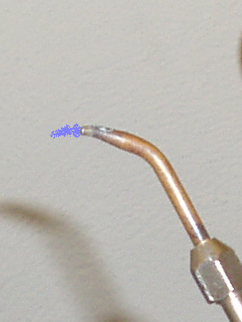
Figure 19. Size and Shape of Intense H₂/O₂ Flame.
  - Under the microscope, use the diamond-tipped scribe to trim the tapered end to the desired geometry. (see Figure 20 below)
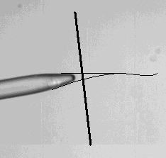
Figure 20. Typical Tip After the Flame Cut; Typical Trim Point and Resulting Tip After Flame Polishing.
  - Using the torch – only a gentle hydrogen flame – polish the very tip of the fiber. This melts the flat end left by the scribe into a more rounded point. It a very intense flame is used, it will melt the glass too quickly and actually blow the tip over.
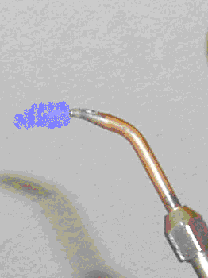
Figure 21. Flame Size and Shape for Flame Polishing.
  - Ensure that about 10 mm of the glass (including the tip) is exposed beyond the jacket. If not, use the stripper to strip off any excess of the jacket.
  - Test the fiber.
    - On the back end of the probe, strip off about 7 mm of the jacket and use the fiber cleaver to make a flush cut of the fiber (almost at the point where the jacket is just removed).
    - Apply a small amount of index matching gel to the back end of the fiber and mate it with a coupler using the grey PVC connector. It will help to tape the coupler (and fibers) in place to make sure they don’t move during testing. A reliable connection is made when the tip is the brightest.
    - With one channel of the probe now connected to the Fiberbox, check to make sure that the voltage drops are acceptable by dipping the probe tip repeatedly in a glass of water.
    - If the voltage drops are not acceptable, first try repeating step e. (The most common problem is under-polishing the tip.) If that does not work, remake the tip again.
- With all four of the fiber tips now made and functioning well. Insert the four fibers, back-ends first, into the section of stainless steel tubing (bend the tubing if required). Leave about 1 ½” of fiber exposed from the tip to the tubing. This will help to keep the fibers together so that they can be more easily aligned in the jig.
- Place the jig in the lockable tweezers so that the triangle is pointing downwards toward the table and align the tubing/fibers with the face of the jig. (see Figure 22 below)
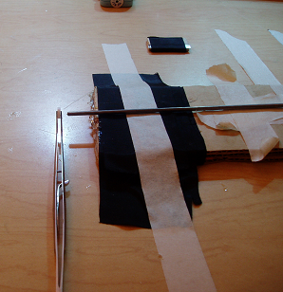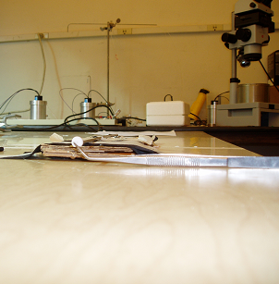
Figure 22. Positioning of the Jig.
- Take one fiber and thread it into the bottom-most hole in the jig.
- Thread the next fiber into the center hole and then thread the remaining two fibers into the two upper-most holes.
- Identify which fiber is threaded into each hole of the jig by gently tugging on the end of each fiber to see which moves. Mark the ends with the Sharpie so that they can be easily identified.
- The next four steps will have to be done quickly (within the 5 minute cure time of the epoxy).
  - Mix the epoxy thoroughly with a toothpick and apply the epoxy only along the jacket of the fiber (do not place epoxy on the glass of the fiber). Start about 3 inches from the exposed glass and apply the epoxy to the upper and undersides of the fiber bundle being careful not to pull the fiber ends out of the jig. Continue to cover the fiber bundle with epoxy until you are about 1 inch away from the exposed glass.
  - Holding the fibers in place, pull the stainless steel tubing up toward the tips. As the tubing moves it will pull the epoxy along with it, so be sure to clean off any excess with a toothpick. Pull the tubing to about ¼” away from the exposed glass.
  - Having identified which fiber is threaded into each hole, adjust the lengths of the fibers in the jig by pulling on the end of the appropriate fiber. The 3 outer fibers should all be set at the same length with the central fiber approximately 2 mm longer.
  - With the fiber lengths now set in the jig, hold the back end firmly and gently push the tubing so that the glue/tubing is almost near the exposed glass. Be sure to remove any excess glue from the SS tubing.
- Allow the glue to dry. Wait at least 30 minutes to allow the glue to cure more.
- Once the glue has dried, carefully pull the probe from the jig and place the probe securely so that the probe tips are safe from hard impacts.
- Secure any appropriate fittings on the probe (for insertion into a reactor) by running them up the back of the probe.
- Plug in the fibers to the fiberbox.
- The 4-point probe is now ready for use.

